|  |
| --- |
| Train Community  A crowdsourced mobile application |
| Proposed by Thusithanjana |



## Train Community

### **A crowdsourced mobile application**

This document is prepared based on the discussed topics in the skype meeting on the 1st of January 2020 with Mr. Hiran Milinda.

#### Key points

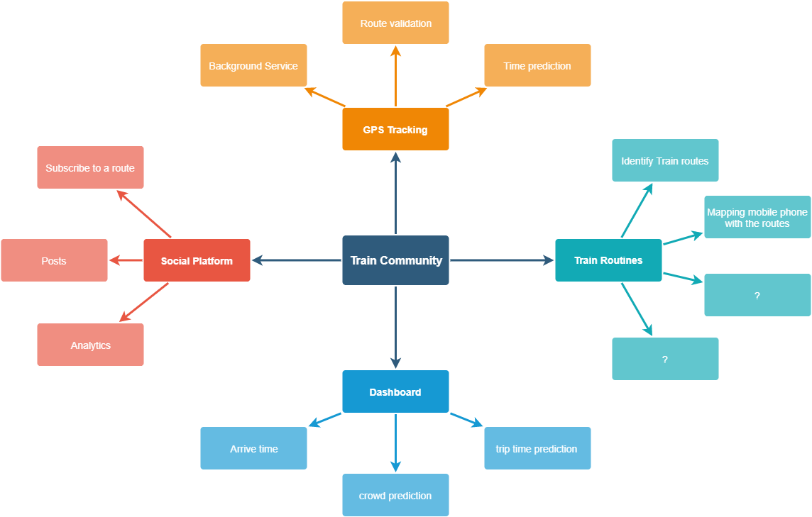

Figure 1: Key points of the discussion

## Introduction

According to the discussion, a mobile application to be developed as a social app. Users will able to publish posts about their commute. Users can subscribe to a certain topic that is related to their travel route, and the user will receive posts based on that route. Ultimately users should be able to get the time of arrival, condition of the train and estimated time to reach their destination. The application model is like Reddit and Twitter.

## Social Platform

It is discussed to use routes as topics. Here routes represent the trains that travel between popular train stations (Ex: Colombo Fort to Polgahawela). Users who wish to go on a route can receive posts that are posted under that topic.

## GPS Tracking

By installing this application, users are agreeing to share their GPS location while this application is in use. Algorithms and methodologies are to be developed to validate their routes and to do the necessary calculations to achieve the main objectives.

## Train routines

All train routings should be identified beforehand to develop the application.

## Dashboard

Users will be able to see a detailed view of their preferred trains on the dashboard. It should be displayed the estimated arrival time, scheduled time, possible alternative options, condition of the train (Crowded or not).